SPRING SEMESTER SENIOR DESIGN
FINAL DESIGN DOCUMENT

Group R01: Aldrin Abastillas, Bezhou Feng, Lisa Jiang, Ryan Nakasone

Abstract
Skin diseases are one of the most prevalent health problems in the U.S., with rates exceeding even obesity. For skin cancers like melanoma, early diagnosis is crucial; the survival rate drops from 95% to 19% as the condition progresses. However, dermatologist visits can be costly and time-consuming. If a situation does not seem immediately severe, patients are more likely to avoid seeking medical attention and turn to inaccurate self-assessments.
This project aims to decrease the subjectivity associated with self-assessment by creating a system that allows patients to receive quantitative suggestions about their condition. The end product is an image analysis algorithm accessed via mobile phone application. Melanoma and basal cell carcinoma were chosen as targets for a proof of concept. The algorithm analyzes skin by extracting features of asymmetry, border irregularity, color, diameter, and texture. Machine learning is used to differentiate between melanoma and basal cell carcinoma. The initial algorithm was able to achieve a sensitivity of 68.17% and specificity of 79.96% for melanoma detection. Specificity and sensitivity for basal cell carcinoma were 77.08% and 97.85% respectively. The average processing times for the algorithm and total communication time between the phone and server are 0.82 +/- 0.01 seconds and 5.05 +/- 0.44 seconds, respectively.
It can be concluded that it is possible to create a self-assessment algorithm using image analysis and machine learning and that it can be implemented on a server and mobile device. Ability to extract image features is affected by border detection of possible tumors.

Introduction
Approximately one-third of Americans suffer from a skin disease that requires physician care (Johnson, 2004). A study showed that 38% of those that have skin conditions that remain undiagnosed (Hay, et. al, 2006). Visiting healthcare physicians takes time and is costly. If a situation doesn’t seem immediately severe or imposing, patients may be more likely to avoid seeking medical attention. A Deloitte study reports that one in four U.S. citizens forgo seeking medical care when sick or injured; the main concern resulting in this behavior is the cost of healthcare (Deloitte, 2011).
For this reason, self-assessment tools, such as webMD, have become extremely popular. webMD is a online resource that allows people to search for a condition in its database of medical conditions. Its purpose is to provide the user with relevant information to allow the user to draw his or her own conclusions based on symptoms of the condition. However, patients’ overall experiences with tools like webMD on the Internet were judged as excellent: 1%, good: 29%, neutral: 62%, poor: 9%, or bad: <1%. In addition, doctors report that patients come to the office with the wrong diagnosis and thus self-diagnosis can actually cause more harm than good (Potts, 2002). People have problems with self-diagnosis, because they often don’t have the tools to accurately assess the situation. For both qualitative and quantitative measures, the diagnosis may be affected by personal interpretations and subjectivity. For example, coloration could be different based on lighting and size could vary based on the person’s method of measurement.
skinMD was inspired by the need to decrease the subjectivity associated with self-assessment. We have developed an algorithm in MATLAB to serve as a quantitative assessment tool that turns diagnostic characteristics of skin disease into more quantitatively analyzable features. Instead of relying on personal interpretations, people can receive suggestions based on an automated visual analysis of the area of concern. While skinMD is not meant to replace medical doctors, it gives users the extra motivation to seek medical care if necessary. Finally, skinMD will link users to relevant online information for the skin condition.
skinMD has been developed into a mobile application (app) that can be downloaded and installed on mobile phone platforms like Apple’s iOS and Google’s Android. App stores make it simple and convenient to download mobile applications. Thus, by making it available on a mobile app store, skinMD is easily accessible by its users. According to an IbisWorld report, the market for mobile apps is growing at an incredibly fast rate (Ibis). A market research report conducted by MarketsandMarkets projects a compounded annual growth rate of 29.6% for mobile apps (Rohan, 2011). Such a successful market suggests that consumers have responded favorably to the development of mobile apps. We have leveraged the successful adoption of the app market to ensure the accessibility of skinMD.
Currently there are algorithms available that can be used as skin assessment tools. There are only two that are commercially available, MelApp and Skin Scan, both mobile apps, but they are solely used for melanoma diagnosis. Another algorithm is the Color-Based Diagnosis developed at Southern Illinois University Edwardsville. It is a program that processes clinical images to assess skin tumors like melanoma. Rather than targeting only one skin condition, skinMD currently determines the presence of melanoma and basal cell carcinoma. This platform technology can be expanded to provide a more comprehensive solution for skin disease assessment because it can integrate a variety of diseases. An application that can assess a multitude of skin conditions will eliminate the need to prematurely guess what disease one might have.
According to the National Institutes of Health, some of the most common skin conditions are acne, eczema, melanoma, basal cell carcinoma, psoriasis, and dermatitis (NIH, 2008). Each of these conditions has various characteristics that may differ from one another, but they also may overlap with those of a different condition. Characteristics include features of the skin condition’s border, texture, evolution, and color. We have developed skinMD for two skin problems to serve as a proof of concept. skinMD will not only be able to detect the existence of a skin condition, it will also be able to distinguish between the two conditions.
The first skin disease skinMD can detect is melanoma. It is the most aggressive and deadly form of skin cancer. Melanoma results in the abnormal proliferation of the cells that produce the pigment melanin from overexposure to radiation from sunlight. In 2004, the prevalence of melanoma was over 718,000 individuals. Of the percentage of people with melanoma who were actually diagnosed (7.67%), 14.36% cases resulted in death (The Lewin Group, 2005). The American Cancer Society has stated that early diagnosis is extremely important for the successful treatment of melanoma. This skin condition has well-known characteristics, which are asymmetry, border irregularities, coloration, diameter, and evolution of the melanoma. It was decided that this would be the first skin condition that skinMD would be able to successfully assess because it has prominent features that can be extracted by image analysis.
The second condition that skinMD is able to assess is basal cell carcinoma. Basal cell carcinoma is the most common form of cancer found in humans (Bath-Hexel, 2004). It is estimated that 2.8 million cases of basal cell carcinoma are diagnosed every year (Skin Cancer Foundation, 2011). Like melanoma, basal cell carcinoma results from overexposure to the sun. However, unlike melanoma, it usually remains in a local region and is less likely to metastasize. According to the American Cancer Society, basal cell carcinomas are flat, firm, pale areas or small, raised, pink or red, translucent, shiny, waxy areas that may bleed easily. They are also characterized by abnormal blood vessels, a lower area in their center, and/or blue, brown, or black areas. Large basal cell carcinomas may also have oozing or crusted areas (American Cancer Society, 2011).

Objectives
Our main objective was to develop a convenient system that would allow users to easily and accurately diagnose skin abnormalities with a simple picture; it would ultimately act as a service that could provide quick suggestions and preliminary information before seeing a doctor. There needed to be a solution, more accurate and less subjective than Internet diagnosis, that remained both low in cost and time efficient. Our application assesses diagnostic features of skin disease using a quantitative approach. In addition to helping the doctors by decreasing the number of people with incorrect self-diagnoses, a more accurate diagnosis may also encourage people, who would normally have forgone treatment, to visit their doctor when necessary.
To achieve skinMD’s main objective, the primary goals were to successfully develop an image analysis and diagnostic algorithm, set up a server to execute the algorithm, develop applications on mobile platforms that interface with the server, and finally to link users to online resources based on their diagnosis (Figure 1). These links and resources will be stored as information in the program itself and not on the server.
First, the algorithm was to be developed in MATLAB. Edge detection, image segmentation, and texture detection would be implemented to extract features from each skin image and the extracted features would then be compared with the distinct features of diseased skin for each condition to generate a diagnosis.
To make skinMD viable for use on a mobile phone, an external server would have to be set up. All processing of the algorithm would take place on this server because mobile phones lack the processing capabilities to run and execute the MATLAB image-processing algorithm. To set up this server, we would need to seek server space that has the capabilities necessary to run the algorithm.
After the algorithm processes the user’s image data, the results would then be sent back to the phone. The program would provide the user with a database of links and resources. These resources should be relevant to each diagnosis. This information could be accessed by the phone once the diagnosis is received and will be displayed with the diagnosis.
Finally, to fulfill the goal of adapting this program to a phone application, the program would need to be able to run on multiple smartphone operating systems. More than half of smartphone owners either own an Android phone or iPhone (Smith, 2011). Therefore, skinMD was to be developed for these two platforms.

Project Illustration
Figure 1 shows a brief overview of how the algorithm, server, and app interact.
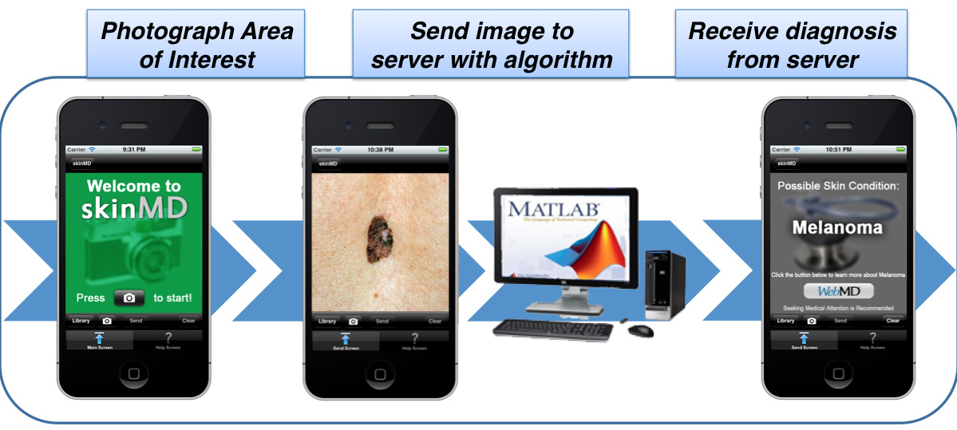
Figure 1: Process overview
Budget
Our entire budget was appropriated towards purchasing software. However most were available for free through the university. The MATLAB software, used for writing the algorithm, was already installed on SEAS and College House computers. There was a $99 yearly membership for joining the Apple iOS Developer Program, but we joined Penn’s developer team, so this fee was already paid for. This membership provided software and resources for creating mobile apps on the iOS platform as well as legal rights to distribute the app on the Apple iTunes Store. For distributing the app on the Android Marketplace, there is a one-time $25 registration free, but this was previously paid for by one of our members prior to starting this project. Thus, this allowed the rest of the budget expenses to go towards renting a virtual server, which runs our MATLAB algorithm and stores the images that need to be processed.
We spent $60.57 for 1024 MB of RAM, 40 GB of storage space, and 400 GB of transfer data per month from Linode.com. Linode normally charges $39.95 per month, but the first month of our hosting was prorated due to an incomplete billing period. A summary is shown in Table 1 below. We are in the process of requesting an additional year of hosting for $431.46, bringing our total expenditure to $492.03, but this allocation has not yet been approved, and thus is not accounted for in Table 1.
Table 1: Expenses
Item | Cost
MATLAB Software | $0
Apple iOS Developer Program Membership | $0
Android Developer Registration Fee | $0
Virtual Server Hosting Package | $60.57
TOTAL | $60.57

Specifications
Disease Detection
The overall accuracy of the algorithm’s disease detection is measured by calculating sensitivity and specificity for melanoma and basal cell carcinoma. Sensitivity quantifies the ability for our algorithm to accurately diagnose the presence of the disease while specificity reflects the ability for our algorithm to accurately diagnose the absence of the disease. For melanoma, our target specification was 80% sensitivity and 90% specificity and for basal cell carcinoma, our target was 70% sensitivity and 80% specificity.
These measurements are based on a study by C.M. Grin on the accuracy in diagnosis of melanoma (Grin, 1990). They represent the average sensitivity and specificity achieved clinically and, although our program is not meant to replace physicians, the algorithm should be no less accurate than a clinical diagnosis in order to remain useful to consumers. For basal cell carcinoma, the specificity and sensitivity are lowered by 10% due to anticipated difficulty in extracting physical characteristics from skin samples. Basal cell carcinoma can often appear the same color as normal skin, whereas melanoma often has a distinct blend of dark colors.
For these measurements, we would like to have a confidence level of 95% and a confidence interval of 5%. This means that we are 95% confident that our sensitivity and specificity meet the specifications within 5%. In order to determine the sample size of photos we need for each skin condition, we used Cochran’s formula, which resulted in a necessary sample size of 384 photos for each skin disease (Cochran, 1963).

Program Processing Time
Processing time is the total amount of time a user spends waiting for an assessment upon submitting an image from the mobile application. Our target specification was a maximum wait time of 60 seconds. This threshold is based on Apple’s Human Interface Guidelines, which state that the majority of users will wait no more than one minute when evaluating a new application (Apple Inc., 2011).

Ease of Use
Ease of use is correlated with how many interactions the user must perform with the application to produce a desired result. Therefore, it was decided that the main interface for the client-side smartphone application would only have one button to take a picture and one button to both send and receive data to and from the server. All app functionality would be available from one centralized menu. To determine users’ overall impressions of the program, they were to be asked questions rating their satisfaction with aspects of the program and their overall experiences. Satisfaction ratings for each category on the survey should be at least 80%.

Cross-Platform Compatibility
The smartphone application would need to support the Android and Apple iOS operating systems. To reach as many users as possible while still utilizing the advantages of the smartphone platform (i.e. camera and internet access), Android and Apple iOS were chosen. Collectively, these two platforms account for 67.5% of smartphones used worldwide (Yarow, 2011).

Full Description
Disease Detection Results
The algorithm is currently able to achieve a sensitivity of 68.17% and specificity of 79.96% for melanoma detection. It achieves a sensitivity of 77.08% and specificity of 97.85% for basal cell carcinoma detection. Thus the specifications were met for basal cell carcinoma detection, but not for melanoma. Sensitivity and specificity are calculated using the following equations:
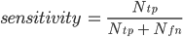
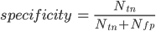
In both equations, N_{tp} is the number of true positives, N_{tn} is the number of true negatives, N_{fn} is the number of false negatives, and N_{fp} is the number of false positives.
The above values were calculated using a testing set of 1034 images, of which 384 were basal cell carcinoma, 465 were melanoma, and 185 were healthy skin. Images were collected from the online database DermNet NZ and from the research lab of Dr. Scott Umbaugh in Southern Illinois University Edwardsville; all images were previously diagnosed and labelled by dermatologists. The healthy skin database included pictures of moles, lesions, and bumps that had been pre-diagnosed as healthy as well as pictures that were taken manually of group members’ own skin. Although the amount of healthy skin images is below the desired number of 384, because the decision classification is evaluated by comparing melanoma versus healthy and basal cell carcinoma images or basal cell carcinoma versus healthy and melanoma images, the size of the sets in each comparison are over 384, so the results are still statistically significant.

Program Processing Time Results
From image upload to assessment reception, the overall processing time of the system is 5.05 ± 0.44 seconds. This value was the average performance over 21 runs of the program using an iPhone 3GS connected to the AT&T 3G cellular network. Timing began as soon as the phone began uploading data to the server, and ended once the phone application displayed a result. Thus, we exceeded the initial specification of 60 seconds.
The average processing time of the MATLAB algorithm alone is 0.81 ± 0.01 seconds. 1750 images were used during testing and the algorithm was running on a Linode 1024 server. Timing began when MATLAB read in the image file and ended when an assessment score was returned. From this, we conclude that the majority of the processing time is in transferring image files from the phone to the server, rather than actually processing the image.

Ease of Use/Cross-Platform Compatibility Results
Applications that send and receive data from the analysis server were successfully created for both the Android and iOS platforms. The final interfaces for the iOS and Android app both meet the requirement of having one button for each of the main functions: one to take the picture and one to both send and receive data. Screenshots are shown below in Figure 2 with the Android interface on the left and the iOS interface on the right. A user-experience survey was distributed to Penn students, which asked them to rate the usefulness and ease of navigation of the camera, results, help, and about screens, how often it crashed, and an overall satisfaction rating. With a sample size of 25 students evaluating a beta version of the app before it was publicly available, the results are as follows: overall navigation ease - 93%, usefulness of FAQ - 89.6%, not freezing or crashing - 100%, and an overall satisfaction of 88.8%. Thus, all of these were over our desired satisfaction rating of 80%.
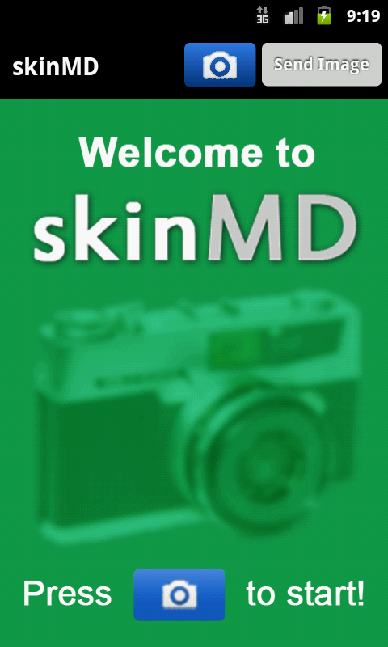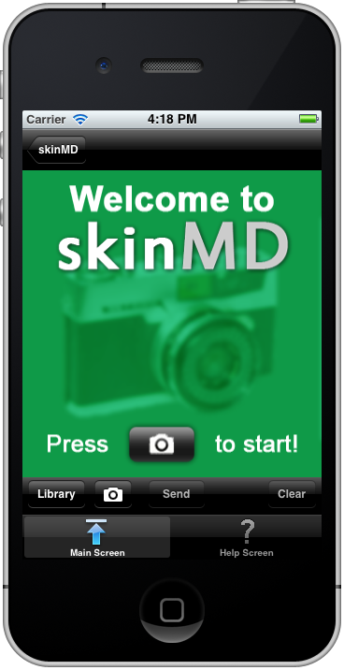
Figure 2: Screenshot of an Android screen on the left and an iPhone on the right

Algorithm Design
Currently, the algorithm functions based on two parts: a support vector machine (SVM) and manual analysis of the feature set. The SVM is an artificial intelligence training method that categorizes inputs into two groups based on a hyperplane developed using features of the inputs. The features used were border irregularity, asymmetry, diameter, red-green-blue color channel ratios, and a histogram of oriented gradients.
The first four features were extracted using code based on edge detection. First, all lighting effects of the image are ignored by eliminating the V channel in the HSV color space. All the edges were found using a Sobel edge detection filter. The edges were dilated to connect gaps in the edges, and the interiors were filled in. Border objects were eliminated to remove any background, and the final area extracted was used from the original image for analysis. Eleven different features were actually extracted from the selected area of interest including color difference from surrounding skin, average color values for the red green blue channels, standard deviation for the red green blue channels, texture difference from surrounding skin, border irregularity, and asymmetry. However, only border irregularity, asymmetry, diameter, and red-green-blue color ratios were used as they were the ones that proved useful in the SVM.
Another feature calculated, was the histogram of oriented gradients (HoG), which is a distribution of local intensity gradients. This was used to characterize local object appearance and shape. The image was divided into a grid of cells, a histogram of gradients was computed for each cell, and each cell was grouped into blocks. Based on a paper published by Dalal and Triggs, the optimal bin size and number of orientation bins for the histograms were eight and nine respectively (Dalal & Triggs, 2005). These measures were also implemented in the current HoG code. Because the local shape information describes the distribution of intensity gradients without precise information about the location of the edges themselves, this was passed into the SVM as a one-dimensional vector without loss of functionality.
A training model for the SVM was created from features extracted from 50 images of melanoma, 50 images of basal cell carcinoma, and 50 images of healthy skin. However, since the SVM is based on a binary classification system, a training model was created separately for melanoma and for basal cell carcinoma.
The manual feature calculations were added, because a large set of features was inputted into the SVM and everything was weighted with equal value. In addition to the four features from border irregularity, asymmetry, diameter, and red-green-blue color channel ratios, the histogram of oriented gradients was actually a 1x81 length vector. Essentially, the SVM used 85 features to determine the hyperplane. This was a problem, because each point in the HoG was weighted equally with each of the other four features. This resulted in a huge weight on the HoG data compared to the extracted feature set. Therefore, the first four features were manually analyzed to determine their relationship with the two skin diseases.
The SVM was combined with the manual feature calculations to improve overall accuracy of the program. A three column prediction array was used, with the columns one, two, and three representing points in favor of melanoma, basal cell carcinoma, and healthy skin respectively. The column with the disease that the SVM predicted received one point. The points from the manual feature calculations were added based on analysis of histograms generated for the values in each feature. As shown in Figure 3a-d, the distribution of data varied among the three different conditions, and points were added based on the feature value and how well it fit into each distribution. For example, in the histogram of infected area border irregularity, healthy skin had an average irregularity less than 2 pixels. Therefore, for the prediction array, if the area had an irregularity greater than 2 pixels, a point was added to BCC and a point was added to melanoma. Since the infected area was much more likely to be melanoma if the irregularity was greater than 10 pixels, another point was added to melanoma if the irregularity was greater than 10 pixels. The disease with the most points within the prediction array represented the final diagnosis.
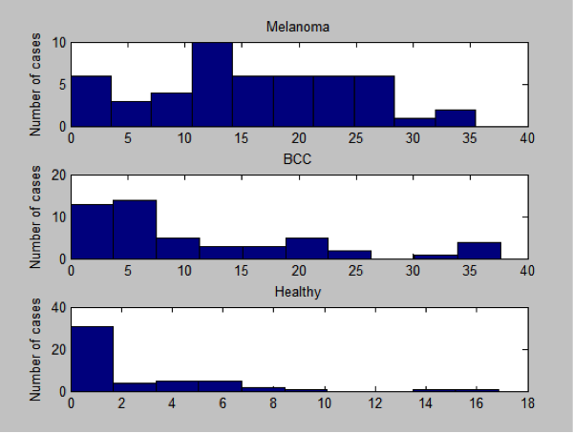  Figure 3a: This histogram shows the distribution in border irregularity of the infected area in pixels. The higher number represents a higher difference in pixels. | 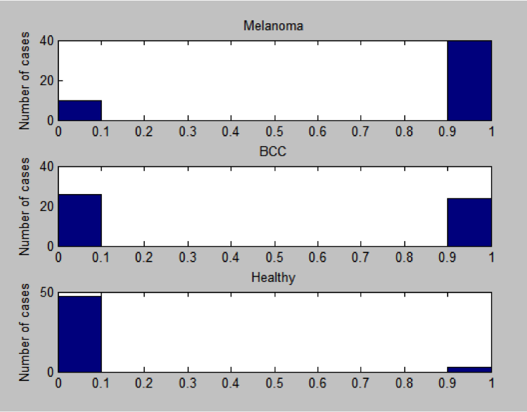  Figure 3b: This histogram shows the distribution of the asymmetry of the infected area. This feature was a binary with 0 representing symmetric and 1 representing asymmetric region.
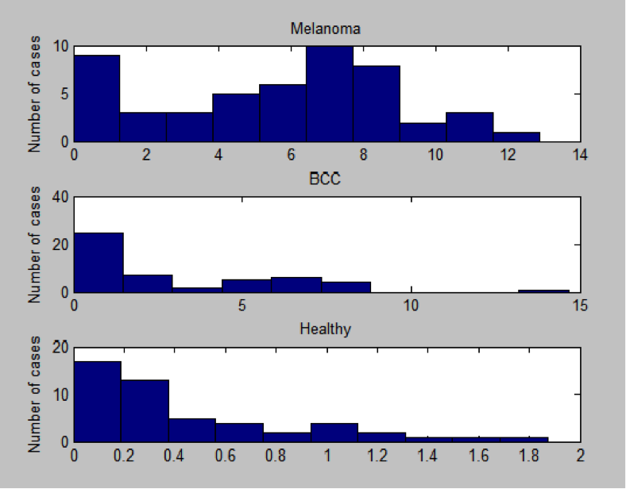  Figure 3c: This histogram shows the distribution in diameter of the infected area in millimeters. The diameter has a value of 0 if nothing is found. | 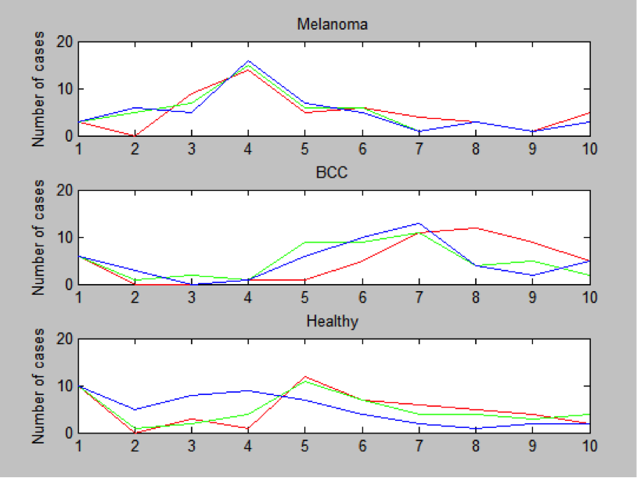  Figure 3d: This line chart represents a histogram of the average red-green-blue color channel values. The value in the red channel is shown in red, green in green, and blue in blue.

To arrive at the final algorithm, several iterations of editing and restructuring had to be implemented. Originally, the training set consisted of 200 images, all 11 features were used in the SVM, and no histogram of oriented gradients was used. When this original algorithm was used on the testing set, the predictions resulted in a high overall accuracy (approximately 85% for melanoma and 76% for basal cell carcinoma). However, it was found that using 200 images overtrained the data, and some of the features were not representative of the condition and actually reduce accuracy. The optimal configuration was found by trying different combinations on the testing set and choosing the configuration with the highest overall accuracy. A literature search was performed on different features used to classify images, which showed that the HoG method was the most accurate and applicable. The HoG was implemented with various bin sizes, but the optimal bin size was the same as that found by Dalal & Triggs for human detection. The edge detection algorithm was also modified; it originally used different sets of filters and different configurations dilation and edge finding thresholds. The optimal

Server Design
The server design went through several revisions in order to optimize analysis speed and scale for large numbers of users submitting images. Initially, the server consisted of two components: a Python Flask web server and a MATLAB program that ran on-demand (i.e. a new MATLAB process would be launched whenever a user uploaded an image). The Flask server was to handle users submitting and requesting data from the server as well to manage a database of images and results. Flask would launch the MATLAB program as required and funnel image data for analysis. However, local testing on a personal computer showed that this approach was very resource intensive. If multiple users submitted images, MATLAB would be started several times, causing a massive slowdown in analysis speed.
To counteract this, we changed the MATLAB program to run constantly in the background. Flask would write files to a shared storage directory that MATLAB scanned every 5 seconds. MATLAB would then write the analysis results to a database accessible to Flask. This approach gave good speed results on local testing, and was consequently how our server initially handled requests.
However, once our server went live on the internet, we realized that only one user at a time was able to submit requests to the server. This is because Flask is single-threaded and processes requests one by one. In addition, because we wanted to host the web page for our product on the analysis server, we found that Flask did not have a smart caching strategy. That is to say, if a user requests a static asset, such as an image, Flask will run through a processor intensive Python script to locate where the image is on the server every single time, rather than store the location and redirect future users to it.
Therefore, we added two programs on top of Flask to make network traffic handling more efficient. Directly facing the internet is a program called Nginx, which is used to cache data for fast retrieval by web browsers. Nginx passes the data it receives to a second program called GUnicorn. GUnicorn is used to spawn several Flask processes, allowing the server to respond to multiple upload requests simultaneously. The Flask and MATLAB scripts behind these two programs remained unchanged. Testing revealed good performance using this architecture, and thus it is our finalized server design (Figure 4).
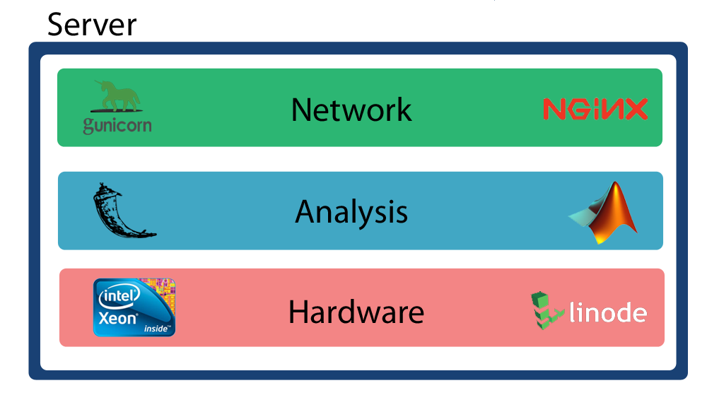
Figure 4: Server Design

Final Process
Figure 5 below shows a flowchart of the overall process starting from when a user opens our app to when they receive their diagnosis. Blocks in red indicate steps on the interface side while those in blue indicate steps carried out by the algorithm.
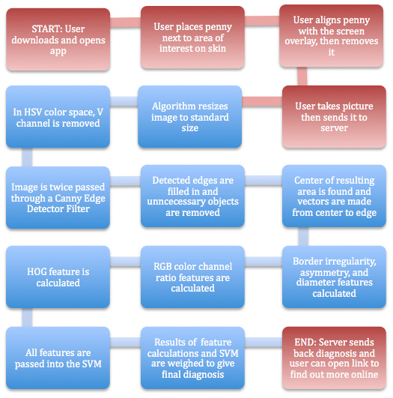
Figure 5: Flowchart of the overall process
Conclusions
It can be concluded that it is possible to create a self-assessment algorithm for melanoma and basal cell carcinoma using image analysis and machine learning. This algorithm can be run on a server and interfaced with a mobile device so that anyone with a smartphone is able to use it. This was an important goal because although melanoma image analysis and classification programs have been researched in several papers in the past, they are not available to the public (except for the two previously mentioned apps that are currently available).
We met all of our specifications except for those addressing the accuracy in classifying melanoma. We think that this accuracy could be increased in the future by addressing two issues. First, the extraction of the possible tumor from the rest of the image is the first and one of the most crucial steps in our algorithm. Although our current edge detection calculations are operational, further refinements will need more research into computer vision techniques, while the research for this project mainly focused on the classification portion of the algorithm.
We also think that further expanding our training database would help the SVM predictions. Currently, the database is comprised of images collected mainly from two sources, and although all the images were taken from different patients, we think that added images from different databases whose images were taken using different camera settings, positioning, lighting conditions, etc. would make the SVM model more flexible to all situations. Overall, we believe the currently developed system serves as an accessible and efficient way for patients to self-assess their skin, and are excited to further improve the underlying algorithms.
References

Apple Inc. (2011, October 12). iOS human interface guidelines. Retrieved from http://developer.apple.com/library/ios/

Bath-Hexell F. J., Bong J., Perkins W., & Williams, H. C.. (2004). Interventions for basal cell carcinoma of the skin: systematic review. BMJ, 329(7468):705.

Cochran, W. G. 1963. Sampling Techniques, 2nd Ed., New York: John Wiley and Sons, Inc.

Dalal, N. & Triggs, B. (2005). Histogram of Oriented Gradients for Human Detection. CVPR, 1:886-893.

Deloitte. (2011). 2011 survey of health care consumers in the United States: key findings, strategic implications. Deloitte Center for Health Solutions.

Grin, C.M., Kopf, A.W., Welkovich, B., Bart, R.S., & Levenstein, M.J. (1990). Accuracy in the clinical diagnosis of malignant melanoma. (p. 763). Archives of Dermatology.

Hay, R., Bendeck, S. E., Chen, S., Estrada, R., Haddix, A., McLeod, T., & Mahe, A. (2006). Disease control priorities in developing countries. (p. 708). Disease Control Priorities Project. Retrieved from http://files.dcp2.org/pdf/DCP/DCP37.pdf

Johnson, M. T. (2004). Deﬁning the burden of skin disease in the United States—a historical perspective. J Investig Dermatol Symp Proc 9:108 – 110

Mayo Clinic. (2010, June 2). Melanoma symptoms. Retrieved from http://www.mayoclinic.com/health/melanoma/DS00439/DSECTION=symptoms

National Institutes of Health (NIH). (2008). Care for conditions from acne to wrinkles. MedlinePlus. 3(4): 22-25.

Potts, H.W.W. (2002). Survey of Doctors’ Experience of Patients Using the Internet. Retrieved from http://www.ncbi.nlm.nih.gov/pmc/articles/PMC1761928/

Rohan. (2011). MarketsandMarkets: world mobile applications market worth US$25 billion by 2015. PR Newswire. Retrieved from http://www.prnewswire.com/news-releases/marketsa ndmarkets-world-mobile-applications-market-worth-us25-billion-by-2015-114087839.html

The Lewin Group, Inc. (2005). The burden of skin disease. Retrieved from The Society for Investigative Dermatology & The American Academy of Dermatology Association.

Yarow, J. (2011, November 15). Gartner: Android market share doubles, iOS drops in Q3. Retrieved from http://articles.businessinsider.com/2011-11-15/tech/30400455_1_ios- iphone-smartphone-market

